Mothercare Ayurveda

Website Contents

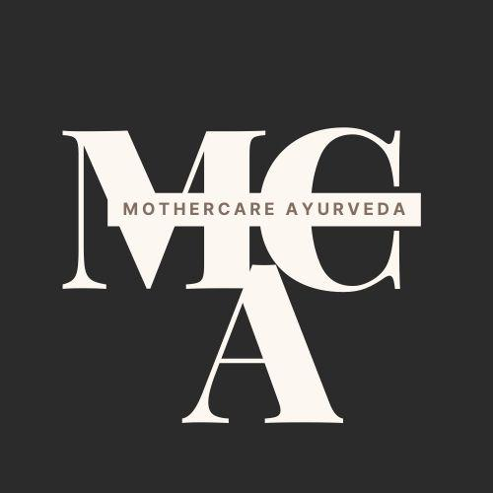 (Logo)

|  |  |
| --- | --- |
| S.No | Content |
| 1 | Home Page  What We Do:   1. Abhyanga 2. Prenatal/post natal massage 3. Diet and Lactation 4. Astrological Consultations |
| 2 | 1. Products 2. Research Use Only Product |
| 3 | Testimonials |
| 4 | Contact Us |



Home Page

# Explore authentic pre and post-natal ayurvedic service at The Mothercare Ayurveda

# Welcome To Mothercare Ayurveda

**What We Do**

# **“Abhyanga” or Postpartum Therapeutic Massage**

Application of oil to the skin followed by massage in specific directions is well known by the name Abhyanga in Ayurveda.

A body massage plays an important role in relaxing and rejuvenating a new mother after the distress of childbirth.

Ayurvedic Massage in specific directions improves blood circulation, facilitates removal of the [toxins](https://www.omicsonline.org/clinical-toxicology.php) from the tissues, Eases breast pain and milk flow and tones the abdomen and other parts of the body easing them back into shape post weight-gain during pregnancy.

Hormonal changes during pregnancy, delivery and motherhood causes severe stress that can be relieved by ayurvedic massage.

.



Our therapist practices abhyanga with an acute awareness of the *energy points* in the body (*marmas* and *chakras*).

Massage sessions can be booked for 20 or 40 minutes.

**Prenatal and Post-natal Yoga Sessions**

Prenatal yoga is a great way to exercise during pregnancy. It can help to improve your sleep, increase your energy levels, and reduce the aches and pains of pregnancy. Yoga can also help to prepare your body for labor and childbirth. Prenatal yoga classes focus on strengthening the muscles used during childbirth, as well as promoting relaxation and stress relief.

 

Postnatal yoga can help you to heal, repair, and support your body after pregnancy and childbirth. It can also help to improve your mood, increase your energy levels, and promote relaxation. Postnatal yoga classes focus on strengthening and toning the muscles of the pelvis and the core, as well as promoting relaxation and stress relief.

Consider taking Yoga classes, if you are pregnant or thinking about becoming pregnant shortly. We also offer online yoga classes.

**Diet Consultation**

For a healthy pregnancy, approximately 300 extra calories are needed per day. These calories should come from a balanced diet of protein, fruits, vegetables and whole grains. Sweets and fats should be kept to a minimum.

Our expert nutritionists will give you right advice on what to eat during pregnancy and to ensure optimum nutrition for you and your baby.

**Lactation Consultation**

Our lactation counselors can help you get off to a good start and will help you how to breastfeed.

The month before birth is the time to choose a lactation counselor.

**Astrological Consultations for Disease treatment**

The Relationship between chronic diseases and the human body is well established in Medical Astrology. Astrology as an ancient science can prove to be beneficial in treating some of the common and chronic diseases. Medical astrology states that each zodiac sign and every planet influences a particular organ of the body.

Talk to our Medical Astrologist to get more details.

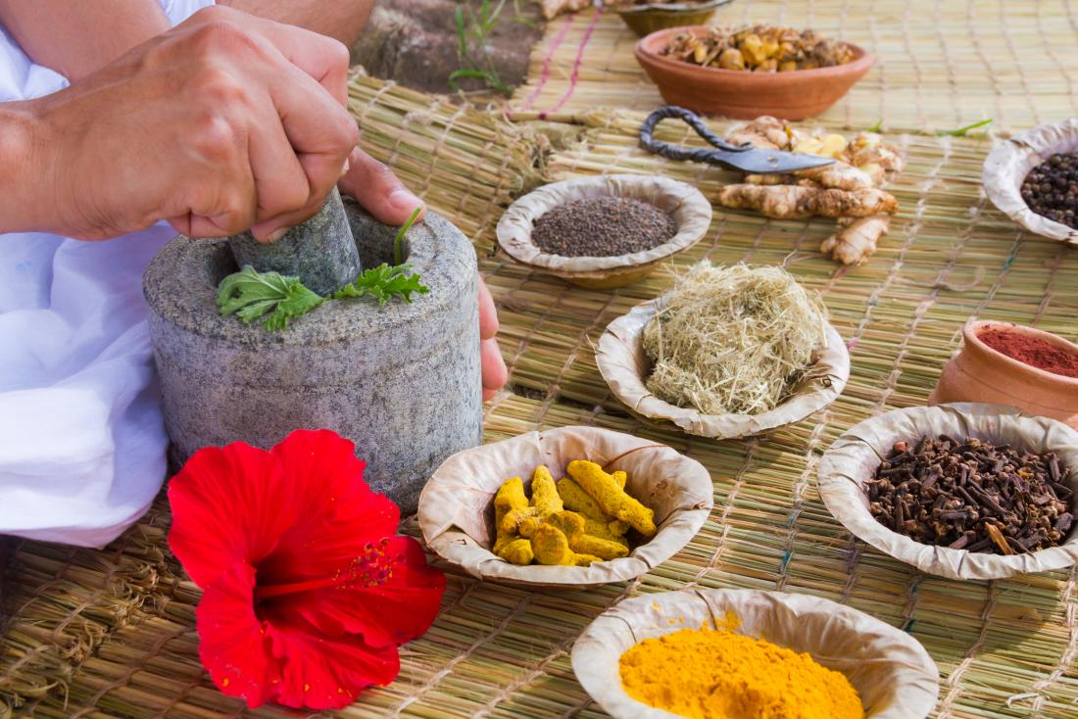

Products

**Hand Made Herbal Soap (Pack of 3)**

Herbal soaps are natural soaps made from plant-based ingredients. These soaps nourish your skin and restore its natural moisture balance. It is suitable for all skin types and is free from parabens, phthalates and sulfates.

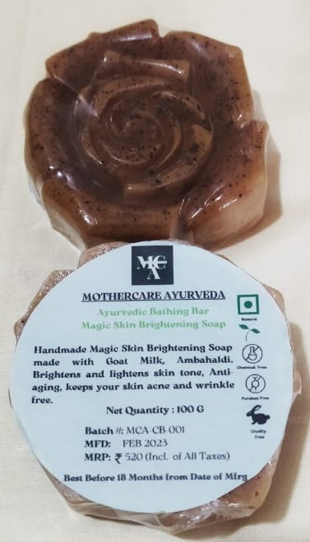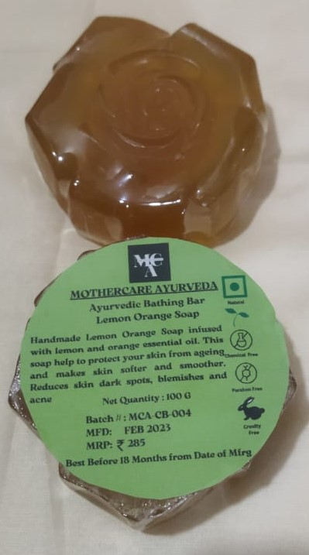

**Babycare Kit**

Includes Babybath Powder, Herbal Kajal and Baby Massage Oil

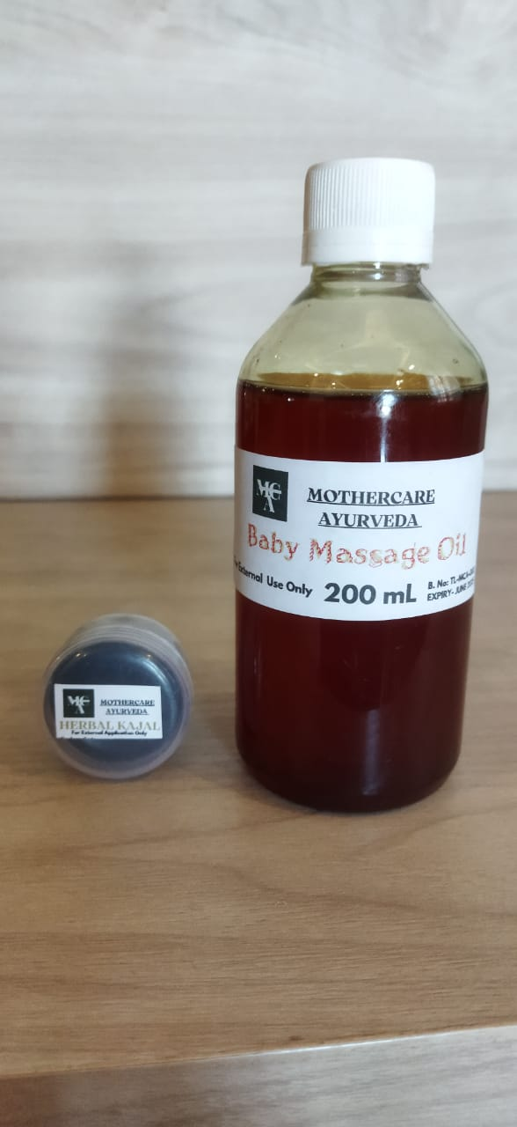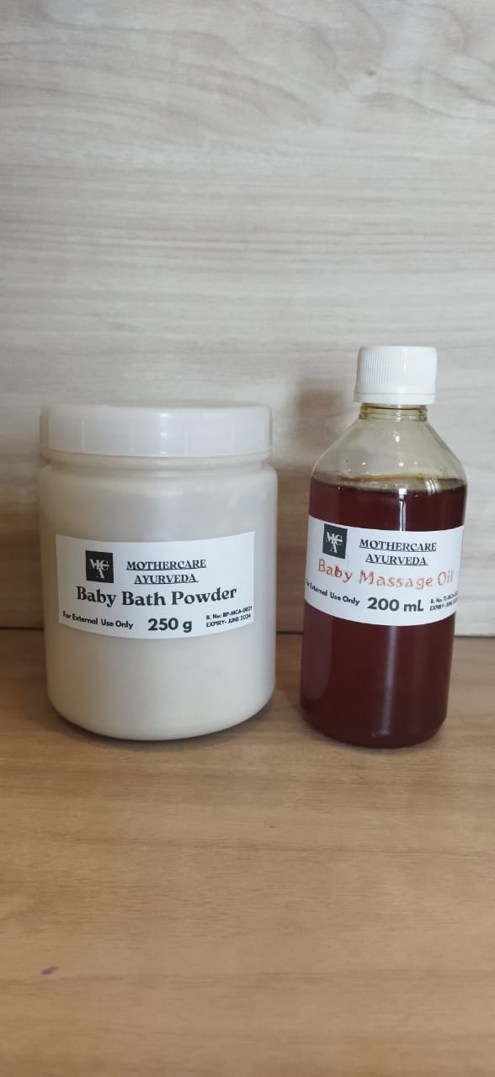

**Mothercare Kit**

Includes Prasava Kashayam, Snana Massage Oil

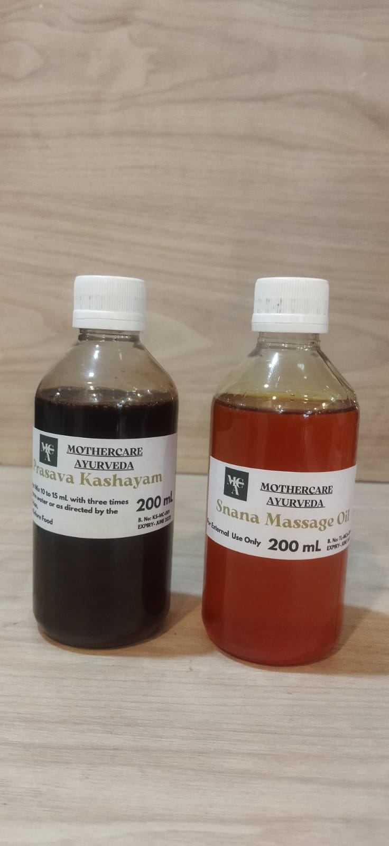

**Research Use Only Product**

**NucleiCare Plant : Nucleic Acid Stabilization Medium for collection and transport of medicinally important herbal plant tissues.**

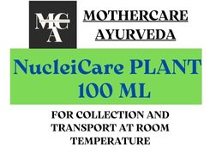

**Testimonials**

Shushrutha, Banashankari: My monthly prenatal massage helps me to relieve pain and increase flexibility. It's a great way to prepare for labor. Thanks.

Lakshmi, Rajajinagar: Thank you mothercare ayurveda for their service. I opt for a post delivery massage. The masseur was skilled and very punctual on their service. Their executive called us up and enquired about the service on a frequent basis. I recommend their massage for every new mother.

Contact Us

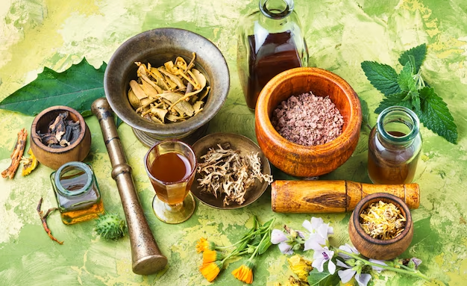

For consultation abhyanga appointment

For abhyanga service, online or offline pregnancy yoga classes and all product related queries

Call us at : +91-8310785641 / +91-7892080158

Email ID : mothercareayurveda@gmail.com

Registered Address:

#42, F1, Ram Nivas

7th Main, 7th Cross

Malleswaram

Bengaluru - 560003

Our Working Hours

Mon-Sat: 10am to 6pm

Follow Us

<https://www.instagram.com/mothercareayurveda6/>

<https://www.facebook.com/profile.php?id=61550243375066>